**Nama : Nida Aulia Karima**

**NIM : A11.2021.13495**

**Kelompok : 4212**

**Tugas Membuat Store Procedure dan Trigger**

**Database Demo**

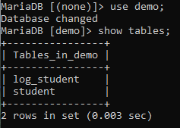

**Tabel log_student**

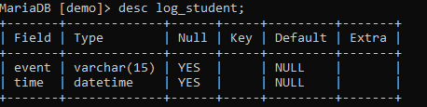

**Tabel Student**

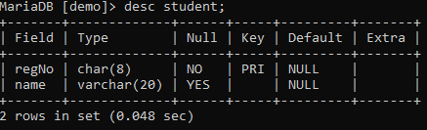

**Insert data**

**Store Procedure**

MariaDB [demo]> delimiter //

MariaDB [demo]> create procedure i_student (xregNo char(2),xname varchar (20))

-> begin

-> insert into student values (xregNo,xname);

-> select * from student;

-> end

-> //

**Hasil :**

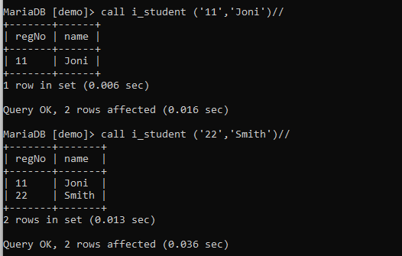

**Trigger dari insert data**

**Store Procedure**

MariaDB [demo]> create trigger i_log after insert on student for each row

-> begin

-> insert into log_student values ('Add data', now());

-> end

-> //

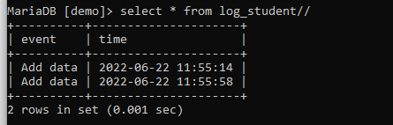

**Update Data**

**Store Procedure**

MariaDB [demo]> create procedure u_student (xregNo char(2), xname varchar(20))

-> begin

-> update student set name=xname where regNo=xregNo;

-> select * from student;

-> end

-> //

**Hasil :**

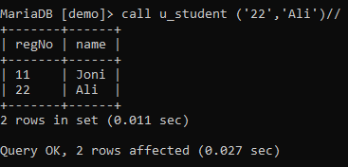

**Trigger dari update data**

MariaDB [demo]> create trigger u_log after update on student for each row

-> begin

-> insert into log_student values ('Update data',now());

-> end

-> //

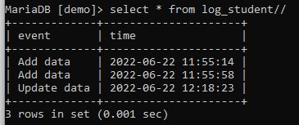

**Delete**

**Store Procedure**

MariaDB [demo]> create procedure d_student (xregNo char(2))

-> begin

-> delete from student where regNo=xregNo;

-> select * from student;

-> end

-> //

**Hasil :**

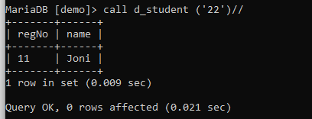

**Trigger dari delete**

MariaDB [demo]> create trigger d_log after delete on student for each row

-> begin

-> insert into log_student values ('Delete data',now());

-> end

-> //

